B.K. Jewellers

**Function Requirement Specification (FRS)**

**Document for**

**“Manufacturing” department.**

Document NO: 001

Date: 20-02-2020

Prepared by:

Group 2

* **Revision History**

|  |  |  |  |
| --- | --- | --- | --- |
| **Revision Number** | **Revision Date** | **Summary of changes** | **Author** |
| **1** | 20/02/2020 | Document made. | Rudra soni |
| **2** | 18/04/2020 | * **Table of content:** Page numbers added. * (**2-MAGE**)**:** Indicators added. * **(2- all elements):** Button background colour state (active) added. * **(2.1-B):** information about support at pg-6 line-6 updated. | Rudra soni |
| **3** |  |  |  |
|  |  |  |  |

* **Table of Contents** -

|  |  |  |
| --- | --- | --- |
| Sr.  No. | Content | Page  No. |
| 1. | Introduction |  |
|  | * 1. Objective | 4 |
|  | 1.2 Scope | 4 |
|  |  |  |
| 2. | Functional Description |  |
|  | 2.1 Accountant | 4 |
|  |  |  |
| 3. | System hardware | 10 |
|  |  |  |
| 4. | Security | 10 |
|  |  |  |
| 5. | Regulatory requirement |  |
|  | 5.1 Accurate record generation | 10 |
|  | 5.2 Timeouts | 11 |
|  | 5.3 Operational system checks | 11 |
|  | 5.4 Electronic signature manifestation | 11 |
|  | 5.5 User password controls | 11 |
|  | 5.5.1 Password expiration | 11 |
|  | 5.6 Additional system controls | 11 |
|  | 5.6.1 Event logging | 11 |
|  | 5.6.2 System access | 12 |
|  | 5.6.3 Input checks | 12 |

1. **Introduction**
   1. Objective:

This is the functional requirement specification for “Manufacturing” functionalities used by manufacturing department of **B.K. Jewellers.**

The function requirement specification is details the capabilities and functions that the software must be capable of and reliably perform functionalities.

* 1. Scope:

This document applies to the “Manufacturing department” of software. The document will address the functions of “Manufacturing department” must be able to successfully perform primary business requirements. The focus is on what the “Manufacturing department” must do.

1. **Function description**
   1. Manufacturing head

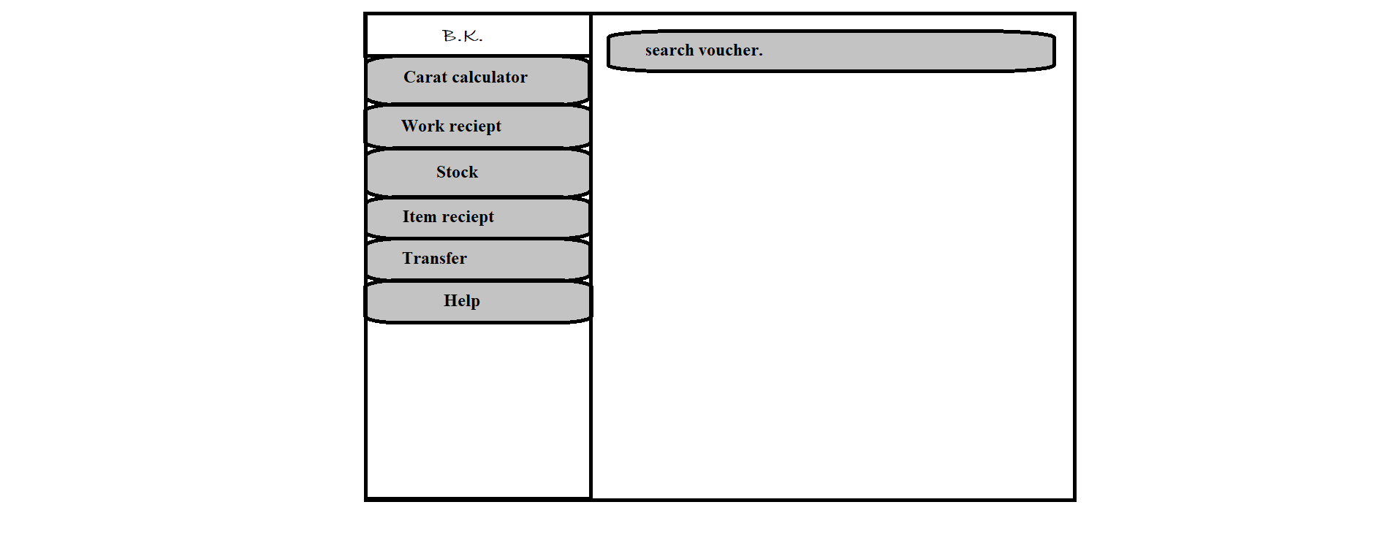

H

G

F

E

D

C

B

A

1. Logo

* Type: image
* Use: only for design
* Events: none
* Source: BKlogo.png

1. Carat calculator

* Type: button
* Text on button: Carat calculator
* Background colour(Active): gray
* Use: to calculate amount of mixture to done for making exact carat value of gold/silver.
* Events:

click:- A calculator in small window at enter will be displayed.

Hover:- display information (text) “carat calculator.” below mouse arrow.

* Functions:
* When button is clicked a small calculator window will be displayed in centre.

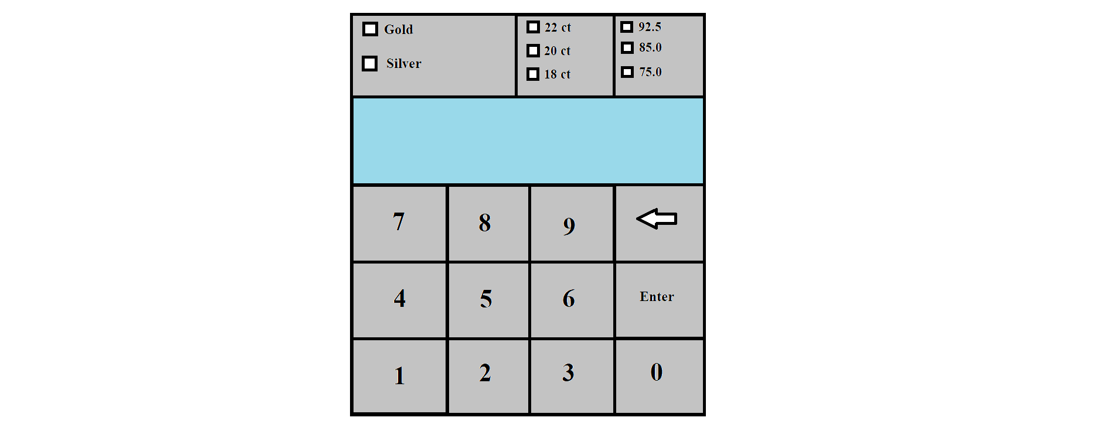

* First, user will have to click on one checkbox given for Gold and Silver, if user selects Gold then he/she will be able to select values for carat (22ct, 20ct 18ct), else for silver (92.5, 85.0, 75.0).
* Second, user will have to enter values form number-pad (“characters are not supported”), these values are considered as weight from which user wants to make jewellery. If any correction there is backspace option available on calculator which deletes one entry.
* Third, user will have to click “Enter” from calculator and data will be sent for process.
* Fourth, output appears in “rows”, first row indicates gram of pure gold/silver and second layer indicates gram of RAI (material used for mixing in gold/silver).

1. Work receipt

* Type: button
* Text on button: Work receipt
* Background colour(Active): gray
* Use: used to generate work receipt for record when every new item will be started to made.
* Events:

click:- navigate user to preformatted receipt for manufacturing department.

Hover:- display information (text) “work receipt.” below mouse arrow.

* Functions:
* When clicked user will navigate to preformatted receipt for manufacturing department in edit mode.
* Automatic new receipt number will be generated.
* User will have to enter worker name, item type and weight, give raw material, image of item, any extra material given, start date and assumed end date.
* After entering all details user click on “submit” button placed at bottom-right corner of window.
* When submit button is clicked receipt will be sent to get printed via connected printer.

1. Stock

* Type: button
* Text on button: Stock
* Background colour(Active): gray
* Use: to keep record of available stock of raw materials.
* Events:

click:- navigate user to MS Excel sheet (mfgstock.xlsx).

Hover:- display information (text) “stock.” below mouse arrow.

* Functions:
* When clicked user will navigate to MS Excel sheet (mfgstock.xlsx).
* User will have to enter all entries manually in respected rows and columns.

1. Item report

* Type: button
* Text on button: Item report
* Background colour(Active): gray
* Use: to generate a report of manufactured jewellery.
* Events:

click:- user will be navigate to new window which contains preformatted report (source: mfgreport.xlsx) in edit mode.

Hover:- display information (text) “jewellery report.” below mouse arrow.

* Functions:
* When button is clicked, user will be be navigate to new window which contains preformatted report (source: mfgreport.xlsx) in edit mode.
* After entering all details (image, gross weight, net weight, labour, carat, type of diamond used.) of a particular item, user will have to click “submit” button placed at bottom-right corner of window.
* When submit button is clicked, the report will be sent to get printed via connected printers automatically.

1. Transfer

* Type: button
* Text on button: Transfer
* Background colour(Active): gray
* Use: to change location of item.
* Events:

click:- navigate user to preformatted location transfer voucher (source: loctransfer.xlsx) into editing mode.

Hover:- display information (text) “location transfer.” below mouse arrow.

* Functions:
* Automatic new voucher number will be generated.
* When button is clicked user will navigate to preformatted location transfer voucher (source: loctransfer.xlsx) into editing mode.
* User will have to add items by scanning barcodes only.
* When a barcode of any item is scanned, the item is shown on right column with its full details submitted on adding to the stock.
* When submit button is clicked a preview of voucher will appear and all scanned items will added to stock of destination location and removed from current location.

1. Help

* Type: button
* Text on button: Help
* Background colour(Active): gray
* Use: to acknowledge the user.
* Events:

click:- a help page (source: help.docx)will appear which contains all information of every single step.

Hover:- display information (text) “help.” below mouse arrow.

* Functions:
* When button is clicked help.docx page will appear in full window.

1. Search

* Type: Search bar
* Placeholder:
* Use: search any invoices and items.
* Events:

click:- activate keyboard for input.

* Functions:
* When user click on search bar keyboard will be activated for input.
* When “Enter” button is clicked after any invoice number or item code is entered software will search matching data from database and show all details and last operation done on item in new window.

1. **System hardware**

The software can run on the minimum standard PC workstation or laptop configuration by **B.K. Jewellers.** This part can be accessible by all PC present in workgroup of organization for “Manufacturing”.

This part of the software does not affect the organization LAN.

1. **Security description**

The manufacturing part is only accessible through the software provided by “BlackSky Systems.” This software or any part of the software does not open from outside the configured environment of **B.K. Jewellers.**

1. **Regulatory requirements**
   1. Accurate record generation:

It has ability to generate accurate and complete record in both human readable and electronic form suitable for inspection & review by regulatory agencies.

The functionality meets the following requirements:

* The ability to generate accurate and complete copies of record in both human readable and electronic form suitable for inspection & review by the agency.
* Users are able to select search queries.
* Users are not able to customise criteria used to view data from search.
* Users are able to export data to MS Excel (linked)
  1. Timeouts:

The software for “Manufacturing department” will not automatically time-out, it is supposed to run after login till the user won’t logout from the system.

* 1. Operational system checks:

The “Manufacturing department” software uses operational system checks for enforce permitted sequencing of steps and events.

* 1. Electronic signature manifestation:

The software has secure data in system through electronic signatures. Data secured with an electronic signature cannot be edited or deleted unless the signature is removed.

* 1. User password controls:

This software does not allow user to change their passwords. Only the administration has this authority.

5.5.1 Password expiration:

Once the password is created it never expires unless user requested to change it.

* 1. Additional system controls:

5.6.1 Event logging:

It includes system login and logout, as well as attempts failures.

5.6.2 System access:

Access to software must be controlled by user access to the LAN controlled by system identification and password.

5.6.3 Input checks:

When appropriate entries may programmatically checked before being accepted by software.(for example, No negative values accepted for item weight.)